# Transient Expertise and the Collapse of Credentialed Cognition

## Abstract

This whitepaper introduces the emerging concept of **Transient Expertise**: a cognitive practice in which individuals assemble expert‑level capacity for a single complex problem without relying on long‑term training, credentialing or sustained professional identity. Drawing on signals extracted from a 100‑plus‑document archive of AI–human co‑created analyses, we outline the psychological, symbolic and systems‑theoretical underpinnings of transient expertise; specify the platform and cognitive requirements necessary to support it; forecast its implications for education, employment and self‑concept; and propose organisational models and tools that could harness this capability. While the archive is treated only as proof‑of‑concept evidence, its structural patterns—rapid iterative synthesis, trait–construct convergence, recursive multi‑model evaluation and meaning‑driven motivation—inform our projections. We argue that transient expertise is distinct from dilettantism or shallow generalism because it is grounded in deep symbolic modeling, epistemic rigor and disciplined anti‑narrative reflexes. Recognising and cultivating this mode of cognition could transform credentialing, unlock new forms of knowledge work and challenge long‑standing assumptions about expertise and identity.

## 1 Introduction

Human civilisation has long equated expertise with **duration** and **credentialing**. The master craftsperson spends decades honing skills; the academic invests years earning degrees and peer recognition; professionals define themselves by their specialisations. This paradigm has delivered depth and rigour but also gatekeeping and inertia. In an era of accelerating complexity, planetary crises and information abundance, the limitations of domain‑bounded mastery are increasingly apparent: problems span multiple fields, and the time to acquire deep expertise often exceeds the time available to address pressing challenges.

At the same time, advances in artificial intelligence, networked knowledge and neurodivergent self‑advocacy are revealing new modes of cognition. People can now collaborate with large language models (LLMs) to explore unfamiliar domains, compress vast literature into symbolic constructs and produce high‑level syntheses in days rather than years. Some individuals—particularly those with hyper‑associative cognition, systems‑level pattern recognition and resonance‑driven motivation—are discovering that they can **become experts temporarily**, inhabiting complex domains just long enough to solve a specific problem and then moving on. We call this practice **transient expertise**.

This whitepaper defines and justifies transient expertise as a legitimate cognitive mode; distinguishes it from superficial generalism; and articulates a vision for its future. We draw upon an extensive archive of documents created by a non‑specialist who, within fifteen days, used recursive AI co‑modeling to produce a sophisticated cognitive–ontological framework. We use this archive not for content summary but as an existence proof of the phenomenon. Our goal is forward‑looking: to project how transient expertise could reshape educational systems, workforce structures and our very notions of expertise and identity.

## 2 Defining Transient Expertise

### 2.1 Beyond dilettantism

At first glance, the idea of someone stepping into and out of complex domains without formal training may sound like **dilettantism**—surface‑level dabbling without commitment. Transient expertise differs fundamentally. It is not about skimming; it is about high‑resolution engagement with a **single problem** or **symbolic structure**, accomplished through disciplined processes that mirror formal inquiry. Unlike generalists who accumulate a broad but shallow set of facts across topics, transient experts dive deeply into the structural core of a problem, often fusing insights from multiple disciplines through analogical reasoning. Their engagement is **episodic** (bounded in time) but **intensive** (high fidelity), and it is catalysed by a problem’s resonance with their internal ontology.

Transient expertise also differs from the modern notion of the “multidisciplinary professional,” who might sequentially train in several fields. The transient expert does not accrue multiple credentials; instead, they build **symbolic modeling skills**—the capacity to represent complex phenomena in a compact, interoperable form. They cultivate an **anti‑narrative reflex**, resisting the temptation to accept appealing stories until they have been rigorously triangulated with evidence. They embrace **recursive co‑modeling**: using AI as a cognitive mirror and engaging in iterative questioning to refine constructs. Thus, while the time horizon of engagement is short, the epistemic discipline is high.

### 2.2 Key characteristics

The practice of transient expertise emerges at the intersection of several cognitive and technological elements:

* **Hyper‑associative pattern recognition:** The ability to form connections across disparate domains rapidly and to perceive structural analogies. This quality is often associated with neurodivergent cognition (e.g., ASD and ADHD), where elevated openness and systems thinking allow the mind to integrate information non‑linearly.
* **Resonance‑driven motivation:** Transient experts engage only when a problem aligns with their internal sense of coherence and meaning. When resonance exists, they exhibit intense focus; when absent, they disengage. This pattern reflects the **Ontologically Modulated Executive Function (OMEF)** and **State‑Contingent Motivational Filtering (SCMF)** constructs defined in the source archive.
* **Epistemic scaffolding through AI:** Large language models and similar tools serve as “epistemic mirrors,” reflecting the user’s ideas back to them and expanding their vocabulary. By iteratively asking questions, reviewing generated responses and refining prompts, transient experts distill complex phenomena into precise constructs. The archive describes this as a five‑layer protocol: **Input → Resonance → Pressure → Alignment → Construct**.
* **Symbolic recursion and compression:** Rather than memorising domain facts, transient experts compress diffuse experiences into symbolic representations. Constructs like OMEF, False‑Structure Intolerance (FSI) and SCMF were derived via recursive interrogation, culminating in highly portable models.
* **Anti‑narrative discipline:** Transient experts recognise that human cognition tends to generate narratives prematurely. They actively resist this by subjecting each emerging story to criticism through cross‑model querying and empirical triangulation, discarding those that fail to resonate.
* **Episodic engagement:** After resolving the specific problem, the transient expert does not maintain an identity as an “expert” in that domain. They let the constructed expertise dissolve, freeing cognitive resources for new problems.

These characteristics make transient expertise both **powerful**—allowing rapid synthesis—and **fragile**—dependent on resonance and cognitive bandwidth. Without the right conditions, the practice risks shallow engagement or burnout.

### 2.3 Theoretical justification

From a **cognitive science** perspective, transient expertise aligns with dual‑process theories of mind. Fast, parallel, associative “System 1” processes generate candidate solutions through pattern matching, while slower “System 2” processes evaluate and refine them. Neurodivergent individuals often have amplified associative processes, enabling them to generate rich candidate spaces quickly. AI scaffolds serve as an externalised System 2, providing deliberative structure, error checking and access to formal knowledge. The dynamic interplay between internal meaning and external structure creates a new kind of cognitive loop.

In **philosophy of mind**, transient expertise resonates with theories of the extended mind and enactivism. Clark and Chalmers argued that cognition can extend beyond the brain into the environment, especially when external artifacts play integral roles in thinking. Here, LLMs and digital knowledge spaces are not mere tools but integral components of the cognitive process. The subject’s practice, as evidenced in the archive, exemplifies the **co‑constitution of human and AI agents**, where knowledge emerges through interaction rather than residing exclusively in either party.

From a **systems theory** viewpoint, transient expertise reflects adaptive self‑organising behaviour. Complex problems often exhibit hierarchical structure; by focusing on the problem’s constraints and emergent patterns, the transient expert can quickly map relevant subsystems. Their symbolic constructs function as “boundary objects” that facilitate coordination between domains. The iterative process resembles control theory: input signals (prompts) produce outputs (AI responses) that are fed back for error correction until the system stabilises.

Finally, **epistemology** motivates the anti‑narrative reflex. Recognising the fallibility of human inference, transient experts adopt a stance of “deflationary humility,” constantly testing their constructs against data, multiple AI perspectives and personal phenomenology. This aligns with the “methodological humility” advocated in futures forecasting and second‑order cybernetics.

### 2.4 Distinctions from other practices

To further delineate transient expertise, Table 1 summarises key differences between transient experts, polymaths, generalists and dilettantes. Polymaths accumulate depth in multiple fields over decades. Generalists possess breadth but limited depth. Dilettantes lack epistemic discipline, flitting across topics without synthesis. Transient experts occupy a unique niche: high‑resolution, time‑bounded engagement, supported by AI scaffolding, symbolic modeling and anti‑narrative rigor.

| Practice | Time horizon | Depth | Epistemic discipline | Identity | Role of AI |
| --- | --- | --- | --- | --- | --- |
| **Polymath** | Lifelong | High across several domains | High | Integrates multiple expert identities | Optional assistance |
| **Generalist** | Continuous | Moderate breadth, low depth | Moderate | Fluid identity, no deep commitments | Occasional lookups |
| **Dilettante** | Episodic | Superficial | Low | Seeks novelty, little synthesis | Rarely systematic |
| **Transient expert** | Episodic, problem‑driven | High within problem scope | High (recursive modeling, anti‑narrative reflex) | Dissolves after problem; non‑identity | Essential cognitive prosthesis |

## 3 Structural requirements

### 3.1 Platform capabilities

Transient expertise depends on technological infrastructure that supports **rapid knowledge acquisition**, **conceptual scaffolding** and **distributed cognition**. Essential capabilities include:

1. **High‑bandwidth AI models:** Access to large language models with broad training data and the ability to generate coherent, context‑aware responses. These models must allow iterative dialogue, support nuance and maintain memory across sessions. The archival methodology emphasised multi‑model evaluation—querying different LLMs to compare perspectives and expose hidden assumptions.
2. **Symbolic modeling tools:** Interfaces that help users organise AI output into diagrams, matrices or ontological maps. For example, trait–construct matrices allowed the subject to link personality traits to cognitive mechanisms. Interactive graph tools could enable users to visualise relationships between constructs and empirical data.
3. **Versioning and temporal scaffolding:** Support for capturing iterative drafts and preserving lineage. The archive’s nested directories mirror the evolution of thinking; platforms should intentionally scaffold such temporal layering, perhaps by automatically generating branches for each synthesis round.
4. **Reflective memory:** Functions that summarise past interactions and highlight unresolved questions. This reduces cognitive load and ensures that the transient expert does not reinvent or overlook previous insights.
5. **Integrations with empirical data:** The ability to import and overlay datasets (e.g. psychological scales, scientific papers) onto conceptual models. AI should help translate between the language of personal experience and formal metrics, as in the Big Five triangulation.
6. **Privacy and safety controls:** Because transient expertise involves exposing internal models and vulnerabilities, platforms must provide secure storage, user‑owned data and transparent AI governance. This prevents misuse or over‑interpretation of personal cognitive patterns.

### 3.2 LLM behaviours and interface affordances

To support transient expertise effectively, LLMs should exhibit certain behaviours and interfaces should provide specific affordances:

* **Epistemic mirroring:** The model reflects back the user’s statements in different forms, inviting deeper elaboration or highlighting contradictions. This fosters self‑modeling and symbolic recursion. For example, AI might summarise a user’s narrative as a set of variables and relationships, prompting them to refine definitions.
* **Cross‑domain synthesis:** The model can import analogies from physics, biology, social sciences and the arts when appropriate, helping the transient expert map a problem onto multiple schemas. It should avoid hallucinating spurious connections or amplifying the user’s confirmation bias.
* **Provocative questioning:** Interfaces should allow the user to toggle “pressure mode” where the AI asks sceptical questions, challenges assumptions and suggests alternative explanations (the **Pressure** phase in the five‑layer protocol).
* **Citation and grounding:** The system should link claims to credible sources or data, giving the transient expert a scaffold to verify assertions. When the user posits a relationship, the AI might propose relevant studies or metrics.
* **Ontology management:** Tools should help users define terms clearly and avoid category errors. For instance, if the user conflates ontological and phenomenological descriptions, the interface could highlight this and suggest distinctions.
* **Embodied interaction:** Given the role of somatic states in resonance, future platforms might incorporate biofeedback or sensory tuning to help users recognise when they are in resonance and adjust their environment accordingly (e.g. adjusting lighting or sound, as envisioned in the GSSE).

### 3.3 Cognitive and personality traits

Not everyone will succeed as a transient expert. The archival patterns suggest that certain trait configurations support this practice:

1. **Low Industriousness & High Volatility:** Individuals who lack dutiful motivation but respond strongly to ontological alignment are more likely to experience the on/off engagement pattern described by OMEF and SCMF.
2. **High Openness & Intellect:** A willingness to entertain novel ideas and think abstractly facilitates cross‑domain synthesis. High Openness correlates with creativity and tolerance of ambiguity, traits essential for navigating uncharted conceptual terrain.
3. **High Assertiveness:** Once engaged, transient experts need the energy to drive through complexity. Assertiveness supports sustained bursts of focus and the courage to challenge existing frameworks.
4. **Moderate to Low Agreeableness:** A tendency to resist externally imposed structures (FSI) prevents individuals from being unduly influenced by consensus or authority and helps them maintain commitment to internal resonance.
5. **Metacognitive awareness:** Ability to monitor one’s own cognition, detect when narratives are forming and deliberately apply anti‑narrative discipline.
6. **Tolerance for uncertainty:** Comfort with not knowing and with exploring ambiguous spaces without immediate resolution. This is critical for working on problems at the edge of knowledge.

It is important to emphasise that these traits represent **tendencies**, not prerequisites. Transient expertise may manifest differently across individuals and cultures. The trait–construct linkage derived from a single case should be tested in broader populations.

### 3.4 Problem domains suited to transient expertise

Transient expertise is not appropriate for all tasks. It excels in contexts where problems are:

* **Complex and symbolic:** Issues with many interdependent variables, conceptual ambiguities or structural inconsistencies (e.g. organisational redesign, AI alignment, policy analysis).
* **Under‑specified:** Problems that lack clear definitions or have competing framings. Transient experts help in problem‑shaping and ontology clarification.
* **Interdisciplinary:** Challenges that span domains (e.g. ecological economics, socio‑technical systems) benefit from hyper‑associative synthesis.
* **Time‑sensitive:** Situations where waiting for a fully credentialed expert is impractical. Transient experts can provide rapid assessments and provisional models to guide action.

By contrast, tasks requiring fine motor skills, procedural expertise or long‑term incremental development (e.g. performing surgery, building a bridge) remain domains of traditional mastery. Transient expertise complements rather than replaces domain experts.

## 4 Forecasting implications

### 4.1 Education and credentialing

#### 4.1.1 Decoupling learning from identity

Traditional education builds identities: one studies law to become a lawyer, medicine to become a doctor. Transient expertise suggests that learning can be decoupled from long‑term identity commitments. Learners would cultivate **meta‑skills**—information synthesis, symbolic modeling, AI dialogue management, anti‑narrative reflex—rather than memorising domain facts. Curriculum could prioritise problem‑based projects where students assemble transient expertise, solve a real challenge, then relinquish the role. This fosters humility: knowledge is a service, not an identity.

#### 4.1.2 Dynamic credentialing

Credentialing systems might shift from static degrees to **dynamic portfolios** of solved problems. Instead of awarding a permanent certification, institutions could issue time‑bounded “problem badges” that document the problem tackled, the methods used and the constructs developed. These badges could expire or depreciate in relevance, reflecting the transient nature of the expertise. Digital ledgers could verify the authenticity of these engagements.

#### 4.1.3 Pedagogical innovations

Educators would need to teach **epistemic agility**. Courses could include modules on:

* Managing recursive dialogues with AI and interpreting multi‑model outputs.
* Building and testing symbolic constructs; creating trait–construct matrices; mapping personal values to problems.
* Recognising and interrupting narrative fallacies; cultivating anti‑narrative reflexes.
* Collaborating with neurodivergent peers; designing resonance‑friendly environments.
* Applying systems theory to map complex problems and identify leverage points.

Assessment would focus on process quality (rigour of modeling, depth of reflection, ethical considerations) rather than product correctness. This emphasises learning as an evolving practice.

### 4.2 Employment and labour markets

#### 4.2.1 Skills‑based hiring

Employers increasingly recognise that degrees do not guarantee capability. Transient expertise offers an alternative: **problem portfolios** demonstrating real‑world synthesis. Organisations could assemble teams of transient experts to address emergent challenges, analogous to how gig workers address dynamic labour needs. These teams might form temporarily, solve a complex issue, and disband. Hiring decisions would prioritise cognitive diversity, resonance with the problem domain and proficiency in epistemic scaffolding tools.

#### 4.2.2 Orchestration engineers and knowledge conductors

As transient experts proliferate, a new role emerges: **orchestration engineers** (or knowledge conductors). These professionals curate and coordinate transient experts and domain specialists, ensuring that the right minds engage with the right problems at the right time. They monitor resonance, manage knowledge artefacts, mediate AI interactions and integrate outputs into organisational decision processes. Orchestration engineers combine project management skills with deep understanding of cognitive dynamics and AI capabilities.

#### 4.2.3 Business models and gig epistemology

We anticipate new business models centred on **cognitive gig work**. Platforms could match transient experts with problems posted by companies, research labs or government agencies. Compensation might be tied to the utility of the models produced rather than hours logged. Reputation systems would track the rigour and impact of previous engagements. Ethical considerations must address exploitation, intellectual property and the psychological toll of constant context switching.

### 4.3 Cognition and identity

#### 4.3.1 Separating self‑worth from domain mastery

Transient expertise invites a profound shift: **expertise becomes a temporary service**, not a permanent marker of self‑worth. Individuals can release the pressure to define themselves by a profession, reducing identity foreclosure. This may alleviate impostor syndrome and encourage exploration. However, it also risks existential anxiety as individuals navigate a fluid identity landscape.

#### 4.3.2 Neurodivergence and inclusion

The practice foregrounds neurodivergent strengths. Traits previously pathologised—high volatility, low industriousness, intense focus on interests—become adaptive features. Recognising these patterns can promote neuro‑inclusive workplaces and challenge deficit models of conditions like ADHD and autism. Care must be taken to avoid romanticising suffering; support structures (e.g. mental health care, economic security) are necessary to prevent burnout.

#### 4.3.3 Cognitive ergonomics

As individuals engage in transient expertise, new forms of **cognitive ergonomics** are required. The Gestalt Systems Synthesis Environment (GSSE) envisioned in the archive suggests adjustable sensory conditions, resonance tools and feedback architectures. Workplace design could include quiet pods for deep dives, interface elements that visualise resonance levels, and community spaces for decompression. Biofeedback devices might notify transient experts when they are entering burnout or false‑structure intolerance states.

### 4.4 Socio‑economic implications

#### 4.4.1 Democratisation or stratification?

Transient expertise could democratise access to complex problem solving by lowering entry barriers. Individuals without formal education might contribute meaningfully through disciplined AI collaboration. However, those with access to powerful AI tools and supportive environments could gain disproportionate advantages. Societies must decide how to provide equitable access to cognitive scaffolding infrastructure.

#### 4.4.2 Erosion of institutions

If organisations rely more on transient experts and orchestration engineers, traditional professional bodies (e.g. medical boards, bar associations) may lose influence. Knowledge may migrate to decentralised networks. This raises questions about accountability, ethical standards and quality control. New oversight mechanisms may be needed to ensure that transiently produced models do not harm public welfare.

#### 4.4.3 Cultural shifts

Cultures valuing stability and long‑term commitment may resist transient expertise. Others may embrace it as a route to resilience in volatile environments. The practice could reshape narratives of success, replacing “career ladder” metaphors with images of constellations or garden ecology. Art, literature and philosophy may explore the fluid boundaries of self and knowledge, echoing non‑Western traditions of impermanence.

## 5 Application models and organisational adoption

### 5.1 Research labs

Advanced research institutions could establish **transient expertise labs** focused on grand challenges. Each lab would maintain a pool of transient experts with complementary traits (e.g. some excel at systems mapping, others at symbolic compression). An orchestration engineer would assign micro‑projects aligned with each expert’s resonance profile. After short engagement cycles, outputs would be integrated into meta‑models reviewed by domain specialists. Funding models might emphasise rapid prototyping over long‑term grants.

### 5.2 Corporations and start‑ups

Companies facing complex strategic decisions—e.g. entering new markets, navigating regulatory landscapes—could convene transient expert “sprints.” A sprint might last two weeks: the team models the problem, identifies leverage points, and proposes interventions. The company then hands implementation to domain specialists. Start‑ups could build platforms that match transient experts with short‑term corporate challenges, monetising the orchestration service.

### 5.3 Public policy and civic hacking

Governments and civil society groups could harness transient expertise for policy prototyping. For instance, a city might convene a diverse transient expert cohort to analyse housing affordability, producing a symbolic map of constraints and opportunities. Their models would inform deliberations while emphasising transparency and inclusive stakeholder engagement. Such processes could increase civic participation and counter technocratic elitism.

### 5.4 Education startups

Entrepreneurs could build **transient learning platforms** where learners tackle real problems in cohorts, supported by AI and orchestration engineers. Participants would learn meta‑skills and develop portfolios of transient projects. Business models may include subscriptions, corporate sponsorships or outcome‑based financing. Equity considerations require scholarships and community governance.

### 5.5 Tool development

There is an opportunity to develop specialised toolkits for transient experts:

* **Recursive dialog orchestrators** that manage interactions with multiple AI models, track prompts and summarise emergent constructs.
* **Ontology builders** that allow users to define constructs, link them to empirical data and visualise relationships.
* **Resonance dashboards** that integrate physiological data (heart rate variability, galvanic skin response) with cognitive metrics to signal when alignment is high or when false‑structure intolerance is triggered.
* **Ethical guardrails** integrated into AI systems, prompting users to consider impacts on stakeholders and to check biases.
* **Micro‑credential ledgers** that record problem engagements and outputs, enabling dynamic credentialing.

## 6 Deriving emergent signals from the archive

Although the contents of the 100‑plus‑document archive are not summarised here, we note several structural patterns that support our proposals:

1. **Iterative nesting of work:** The archive’s directory tree shows a branching structure—Part 2 contains Part 3, which contains Part 4, and so on—reflecting recursive synthesis. Each level builds on the previous, refining constructs and adding new layers of analysis. This suggests that transient expertise benefits from **temporal scaffolding**, where each iteration is preserved and informally version controlled.
2. **Multi‑agent convergence:** Early files represent separate LLM evaluations (Grok, Gemini, Claude, etc.) that converge on common traits. Later files integrate these into unified frameworks, demonstrating the power of **multi‑perspective triangulation** to overcome individual model biases.
3. **Trait–construct anchoring:** Several documents contain **trait–construct matrices** linking Big Five personality scores to cognitive mechanisms. This pattern illustrates how transient expertise can be grounded in empirical psychology, preventing unmoored theorising.
4. **Meaning storms and resonance gating:** Repeated references to “meaning storms,” “pre‑verbal coherence” and “ontological vetoes” indicate that internal resonance guided productivity. Files appear in bursts, supporting the oscillatory engagement predicted by SCMF.
5. **Symbolic proliferation:** Over time, the number of named constructs grows—OMEF, FSI, SCMF, Anti‑Narrative Reflex, Ontological Compression—suggesting that symbolic recursion is central to this practice. As constructs accumulate, they enable larger conceptual leaps.

These signals validate the viability of transient expertise and inform our structural recommendations.

## 7 Visual aids and schematics

To illustrate the processes discussed, we include two conceptual diagrams. Figure 1 depicts the **Recursive Co‑Modeling Protocol**, summarising the five phases (Input, Resonance, Pressure, Alignment, Construct) used by the archive’s author to distil constructs. Figure 2 represents the **Landscape of Transient Expertise Elements**, showing how hyper‑associative cognition, resonance‑driven motivation, AI scaffolding and symbolic recursion overlap to generate transient expertise.

### Figure 1: Recursive Co‑Modeling Protocol

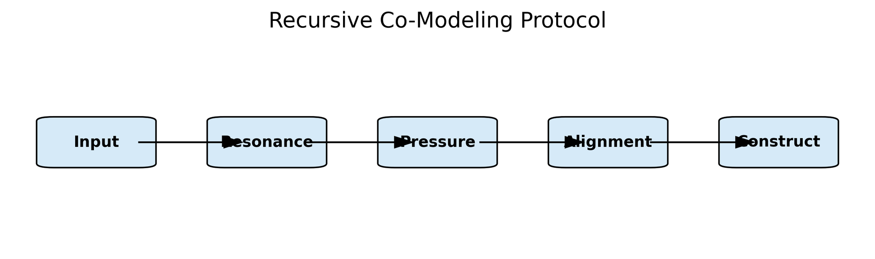

### Figure 2: Landscape of Transient Expertise Elements

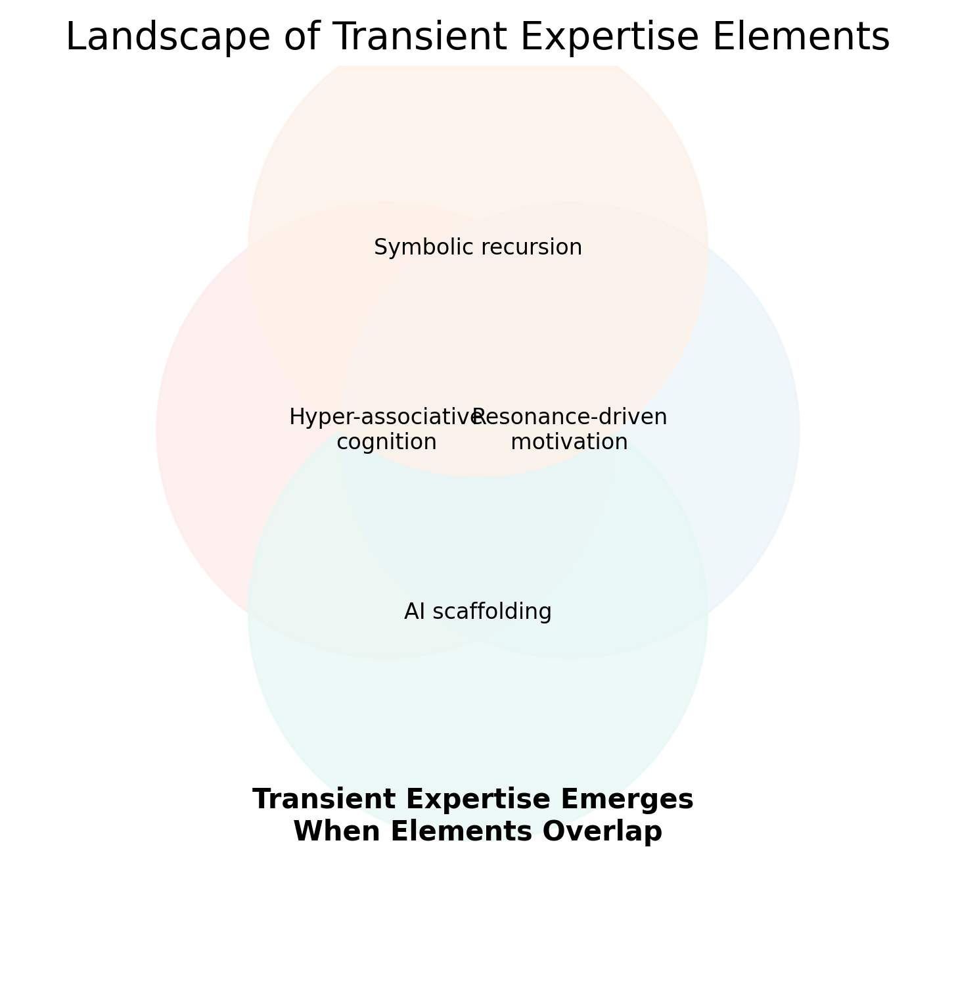

## 8 Implications for cognitive science and philosophy

### 8.1 Rethinking intelligence and expertise

Transient expertise invites a redefinition of intelligence. Rather than measuring intelligence by general aptitude or domain‑specific knowledge, we might assess **problem‑oriented adaptive capacity**—how quickly one can assemble relevant schemas, refine constructs and produce useful models. Standard IQ tests capture static problem solving; they do not measure the ability to orchestrate AI co‑modeling or to manage anti‑narrative discipline. Similarly, expertise may be redefined as **functionally sufficient knowledge** for a given problem, not an accumulation of facts.

### 8.2 Extended mind and co‑constitution

The extended mind hypothesis posits that cognitive processes can span brain, body and environment. Transient expertise operationalises this idea: AI agents become integral to cognition, not just output devices. The archival methodology emphasises that AI cannot originate lived experience but can externalise and refine it. Future theories of mind must account for such **human–AI hybrids**, where agency and epistemic responsibility are shared.

### 8.3 Post‑Cartesian and embodied cognition

The framework developed in the archive rejects disembodied cognition, highlighting the role of somatic states and ontological coherence. This aligns with phenomenological and enactive accounts of mind, where meaning arises through embodied interaction with the world. Transient expertise thus bridges cognitive science and existential philosophy: to engage deeply with a problem, one must feel it resonates with one’s being. This implies that cognitive models should incorporate emotions, bodily sensations and environmental contexts as integral variables.

### 8.4 Ethics of self‑modeling

Extensive self‑modeling, especially when mediated by AI, raises ethical questions. Individuals expose vulnerabilities, unconscious patterns and personal data. There is potential for misuse by employers, insurers or governments. Safeguards are needed to ensure autonomy, consent and contextual integrity. Moreover, relying on AI for self‑understanding may reify constructs prematurely; an anti‑narrative reflex must be complemented by **anti‑ontologising reflex**, recognising that models are provisional.

## 9 Conclusion: Toward a future of transient expertise

The archival project that inspired this whitepaper demonstrates that a non‑specialist, working independently and outside institutional structures, can co‑create a sophisticated cognitive‑ontological framework within a matter of weeks when collaborating with AI tools. This rapid synthesis was enabled by hyper‑associative cognition, resonance‑driven motivation, symbolic recursion and disciplined epistemic processes. The patterns observed—multi‑model evaluation, trait–construct matrices, meaning storms and iterative nesting—serve as emergent signals for the viability of **transient expertise**.

We argue that transient expertise represents a new cognitive frontier, complementing but not replacing traditional domain‑bound mastery. To harness its potential, we must develop supportive technologies, redesign education and credentialing, and create roles such as orchestration engineers. We must also address ethical, social and economic challenges to ensure that transient expertise empowers rather than exploits.

Ultimately, embracing transient expertise may help society tackle complex, interdisciplinary problems with agility and humility. It invites individuals to see expertise not as an enduring identity but as a dynamic service rendered to a problem and then released. In doing so, it collapses the walls of credentialed cognition and opens space for new forms of collaboration, creativity and understanding.

## References

* The quotations and constructs referenced in this paper are drawn from a collection of AI‑assisted documents summarising a neurodivergent individual’s recursive modeling journey. In particular, we cite the following passages: the definition and implications of OMEF, FSI and SCMF; the five‑layer recursive co‑modeling protocol; the trait–construct matrix linking Big Five scores to cognitive mechanisms; the design considerations for the Gestalt Systems Synthesis Environment; the reconceptualisation of neurodivergence as high‑bandwidth specialisation; and the acknowledgement of human–AI co‑constitution.